**Program No.06**

**Program title** Day indicator

**Aim**

To indicate day

**Hardware Required**

Arduino board

Ldr sensor

Buzzer

voltmeter

**Circuit**

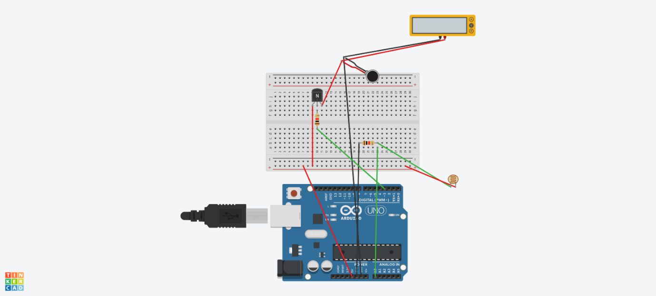

**Code**

void setup()

{

Serial.begin(9600);

pinMode(3,OUTPUT);

}

void loop()

{

float value =analogRead(A0);

Serial.print("\nlight value=");

Serial.print(value);

delay(1000);

if(value>300)

digitalWrite(3,HIGH);

else

digitalWrite(3,LOW);

}